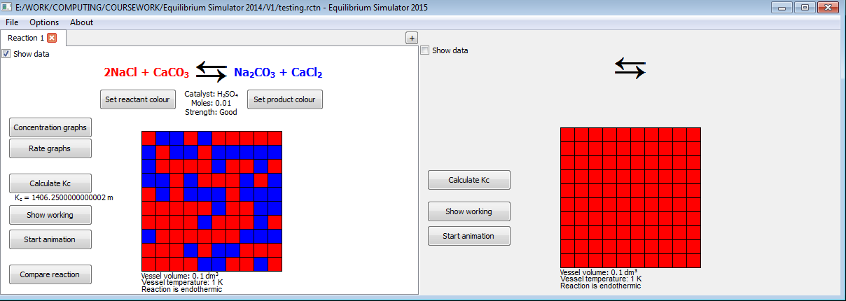EQUILIBRIUM SIMULATOR 2015 USER GUIDE

JAMES CURRAN

CONTENTS

1. Introduction 2
2. System Requirements 3
3. Installation 3
   1. Installing from Disk 3
   2. Using the Installer 4
4. The Interface 5
   1. The Main Window 5
   2. The Menu Bar 6
   3. The “Edit Conditions” Window 7
   4. The Graphs 8
   5. The Worked Solution 9
   6. Common Tasks 10
5. Frequently Asked Questions 10
6. Troubleshooting 11

1: Introduction

Thank you for using Equilibrium Simulator.

This program has been designed to serve as a teaching aid and revision tool, to help students understand the concept of reversible chemical reactions and the effects of changes to the conditions of the reaction. The program’s major features are:

* Worked calculation of equilibrium constant of given reaction
* Simplified animation representing a reversible reaction, adjustable by changing conditions
* Graphs of concentration or reaction rate against time, adjustable by changing conditions
* Side-by-side comparison of reaction data
* Automatic organisation of reaction data for printing
* Simple explanation of how Kc is affected by changes in conditions
* Save and load files exclusive to the program, consisting of up to 5 reactions per file

This user guide deals with the first released version of Equilibrium Simulator, version 1.1.

When reading this document there are a few features readers should be aware of:

* Figure system – some parts of this guide will refer to certain images within the guide as “figure 5”, for example, to help explain a point. Figures are ordered sequentially throughout the text, starting at figure 1. For convenience each image is also labelled with the corresponding figure number and a small caption which may provide further information.

IMPORTANT

* “IMPORTANT” boxes (see figure 1) – these   
  contain important information which the user should be aware of. If the information in these boxes is not considered, you may be unable to run the program properly.

Figure 1: An example of an “IMPORTANT” box.

Please email any feedback or questions to jlscurran@outlook.com.

2: System Requirements

* 30.7 MB free space on the disk where you install the program
* Operating System: Windows NT, 2000, XP, Vista or later; Mac OS X or later; any Linux system
* The program uses 26,696 KB of virtual memory and 39,336 KB of physical memory while running – your system should have well above this amount to be compatible.

3: Installation

3a: Installing from Disk

IMPORTANT

If installing on a personal computer or public network where you are not listed as its administrator, you are likely to be unable to install programs. If this is the case, please contact your administrator or support team, who will take care of the installation.

* 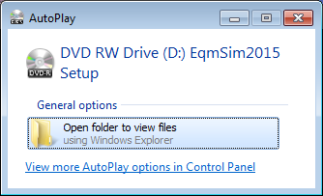Insert the supplied DVD-R, face-up, into the disk drive of your computer. There will be some delay while the disk is being read.
* On most systems a window will appear, similar to that in figure 2, showing what you can do with the disk. Select the option which allows you to view the   
  files on the disk. If such a   
  window does not appear, go to   
  your system’s “Computer”  
  section and select the DVD   
  drive to view the files.

Figure 2: The AutoPlay window, which appears after inserting the disk on the Windows 7 operating systems.

* Locate and select the setup file  
  “Equilibrium Simulator Setup”   
  on the disk.

“Equilibrium Simulator Setup” (or “Equilibrium Simulator Setup.exe”) should be the only file on the disk, and have a file size of 7,802 KB. If you have a disk with any other files on it, or the setup file is not the same size, be careful – the disk is not official, and may actually contain malicious files which could harm your computer.

IMPORTANT

3b: Using the Installer

* 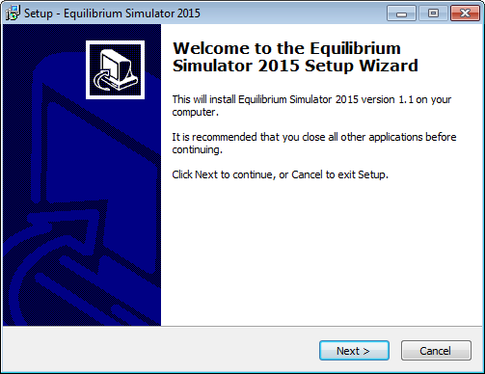A message may appear, asking if you want to give permission for the installer to make changes to your computer. Installation can only begin when you press “Yes”.
* A window will appear, similar to the one shown in figure 3. Follow the instructions in the installer to install the program.
* The installation can be cancelled at any point, but if you run the installer again   
  you have to start from the   
  beginning.

Figure 3: The first section of the installer.

In the second section, don’t select the folders “Program Files” or “Program Files (x86)” to install the program in. The program doesn’t have permission to change files in those folders, so it will crash when you try to run it.

IMPORTANT

* If you did not choose to create any shortcuts, you can run the program by going to the folder you chose to install in and running “main” (or “main.exe”).
* 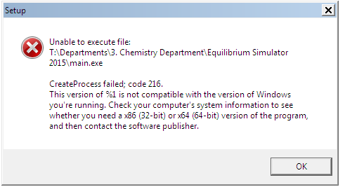When attempting to run the program, you may see an error like the one in figure 4. This is due to trying to run a 64-bit version of the program on a 32-bit system or vice versa. To find out the version required for your system, go to your computer properties to find out whether it is 32-bit or 64-bit. You can request the appropriate version by using the contact e-mail.

Figure 4: The first section of the installer.

IMPORTANT

It is recommended that you do not delete or attempt to edit any of the files that were installed – this can stop the program running altogether. In the event that some of the files are removed, they can always be restored by running the installer again on the same folder.

4: The Interface

The majority of work is done in the main (see section 4a) and “Edit Conditions” (see section 4c) windows, so it is important to be familiar with these.

4a: The Main Window

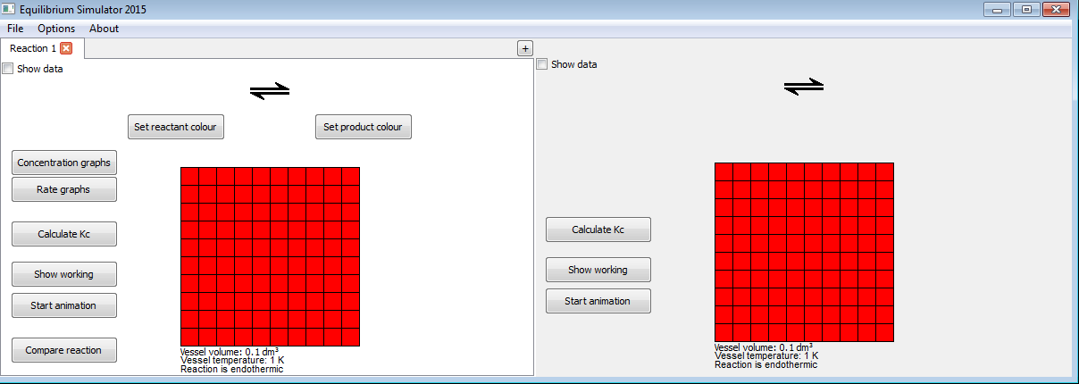

Figure 5: The main window.

1. The left, or ‘current’ reaction window, is the window that you are currently working with. Its details can be edited, and it can be saved on your system.
2. The right, or ‘compared’ reaction window, is a direct copy of   
   when is pressed. This is used for a side-by-side comparison of two reactions. Its details cannot be edited, and it is not saved on your system.
3. The menu bar (see section 4b).
4. The tab bar. Each tab shows one of the reactions in the file you are working on. The lightest-coloured tab is the one you selected most recently. The red “X” button deletes the reaction from your file.
5. The “+” button adds a new, blank reaction to the file, the tab of which is the rightmost tab of . Each file can contain a maximum of 5 reactions.
6. The “Show data” checkbox only shows certain data when checked, in case there is data a teacher would want to hide from students so they can work information out for themselves. This box is unchecked by default. The hidden data is: value and units of Kc; whether or not Kc changes when conditions are changed.
7. “Set reactant colour” allows you to change the colour which represents the reactants in the reaction (red by default).
8. “Set product colour” allows you to change the colour which represents the products in the reaction (blue by default).
9. This is where the reaction taking place is displayed. The formulae of the reactants are displayed to the left, the formulae of the products are displayed to the right, and information about the catalyst is displayed below. This can all be edited using the “Edit Conditions” window (see section 4c).
10. The “Concentration graphs” and “Rate graphs” buttons produce side-by-side comparisons of each reaction’s graph of concentration or rate of reaction (see section 4d).
11. The “Calculate Kc” button calculates the value and units of Kc for the reaction, and displays the result just above the button itself. The “Show Working” button displays a small popup box containing a worked calculation of Kc (see section 4e).
12. The “Start Animation” button begins a simple animation in which represents the reaction. It also causes the graph windows to begin plotting at the same time.
13. The “Compare reaction” button causes to be replaced by an exact copy of , so that the two can be compared when a condition in is changed.
14. The information here describes the volume and temperature of the vessel the reaction takes place in, as well as whether the reaction is exothermic or endothermic.
15. The grid of squares represents the vessel the reaction takes place in. Each square represents a percentage of the chemicals reacting in the vessel. All squares are the colour which represents the reactants at first. During the animation, each square may change from the reactant colour to the product colour or vice versa, symbolizing that reactant chemicals can change to product chemicals and vice versa. The likelihood of a colour change increases as the reaction progresses. When around half the squares have the reactant colour and half have the product colour, this symbolises that the reaction is at equilibrium.

4b: The Menu Bar

Each button in the file menu opens a smaller menu with some useful options.

* The “File” Menu:
  + New: Creates a new file. Only one file can be open at a time per instance of the program. If   
    you have a saved file open   
    already, you will be asked if you want to save again before opening the new file. If you select “No”, you will lose any unsaved changes.
  + Open: Allows you to open a new file.

The program can only understand files ending in “.rctn” (e.g. “example.rctn”) which it has created. Make sure that you only open .rctn files which have been made by this program.

IMPORTANT

* + Save: Saves any changes to the current file in the location where you opened it. If the current file has not been saved before, you will be asked where to save it.
  + Save As: Allows you to specify where the current file should be saved.
  + Print: Assembles the data of the current and compared reaction windows for A4 printing, then displays printing options.
  + Exit: Exits the program.
* The “Edit” Menu:
  + Edit Conditions: Opens the “Edit Conditions” window, where changes can be made to the conditions of the current reaction, as well as other things (see section 4c).
* The “About” button displays the version of the program that you are using. Clicking the version menu does nothing.

4c: The “Edit Conditions” Window

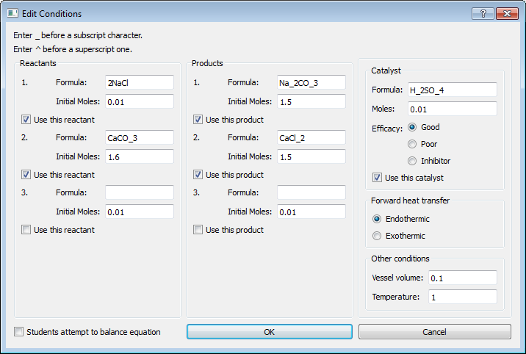

Figure 6: The “Edit Conditions” window.

1. There is currently no support for entering superscript and subscript characters, so the instructions on the top-left must be followed for formulae to display correctly. For example, “CH_3(CH_2)_1_0COO^-“ is displayed as “CH3(CH2)10COO-”. Formulae can be up to 25 characters long, including _ and ^ characters.
2. 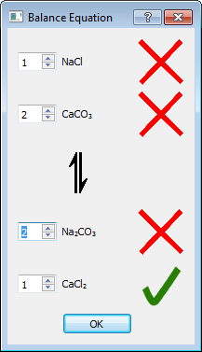It is very important to tick “Use this...” below each reactant, product and catalyst you plan to use. Only chemicals you have selected for use will factor into calculations or be displayed in windows. Also, there is no need to make sure there is valid information for chemicals which you have not selected for use.
3. If this box is checked, all data being used is valid and “OK” is pressed, the main and “Edit Conditions” windows will be hidden while a special window (see figure 6) opens where students can try different values to balance the reaction equation. When “OK” is pressed in this special window, the “Edit Conditions” window and this special window will close and the main window will be shown again. At the moment, the program does not have a facility for balancing equations automatically, so teachers must enter the formulae “pre-balanced”. Because of this it would be prudent to prevent the students from seeing the “Edit Conditions” window while the data is being entered.

Figure 7: The “Balance Equation” window.

1. 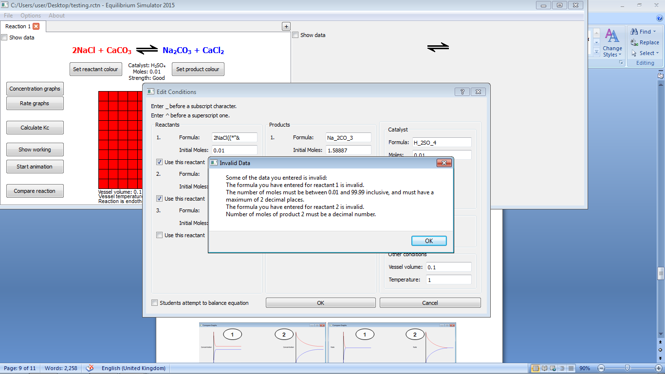When “OK” is pressed, if any invalid data has been entered for any chemicals which will be   
   used, or compulsory factors such as   
   temperature, an error message similar to the   
   one in figure 8 will appear, detailing which data is invalid. If this happens, simply press OK and you will be able to correct the problems listed. If OK is pressed in the “Edit Conditions” window and all data is valid, the window closes normally and the changes are applied.

Figure 8: The “Invalid Data” window.

1. When “Cancel” is pressed, the   
   “Edit Conditions” window closes normally regardless of whether the data being used is valid, but no changes are applied.

4d: The Graphs

These windows appear when “Concentration graphs” or “Rate graphs” is pressed in the main window.

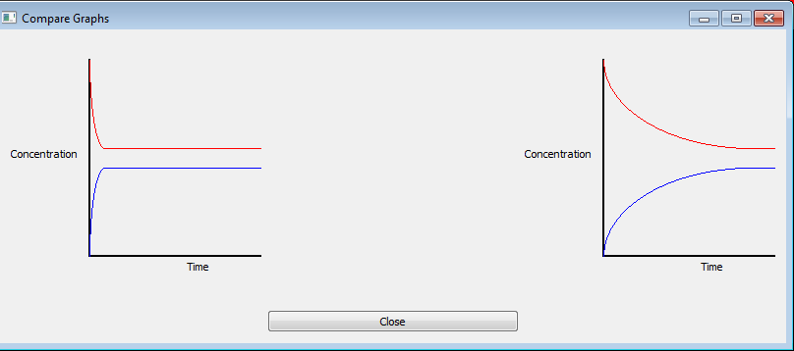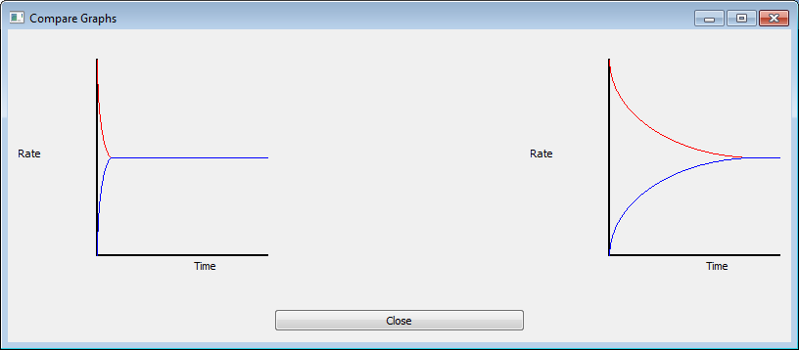

Figure 9: The two graph windows.

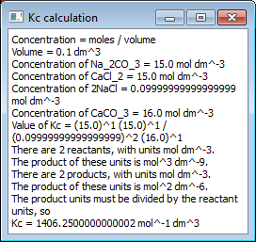

The graphs do not start plotting until the animation has started. To start the animation, press “Start animation” in the reaction window.

1. The graph for the left reaction window.
2. The graph for the right reaction window.

4e: The Worked Solution

This appears when “Show working” is pressed in the main window.

Figure 10: The “Kc calculation” window.

4f: Common Tasks

Creating a new reaction

When the program starts, only a blank reaction is displayed. To add conditions to it:

1. Press “Options” at the top of the window.
2. Press “Edit Conditions”. The “Edit Conditions” window will open.
3. Use this window to edit the conditions of the reaction.
4. Press “OK” to save the conditions. An error will appear if any data you have entered is invalid. You will not be able to save the data if any of it is invalid.
5. The changes will be applied immediately.
6. Pressing “Cancel” will close the window without applying any changes.

The same process can be used to edit the reaction any number of times. If you want to keep the old reaction, a new reaction can be added by opening a new tab. This is done by pressing the “+” button in the middle, towards the top of the window. Tabs can be closed by pressing the “X” button on each tab.

Comparing conditions

1. Press “Compare reaction”. A copy of the current reaction will appear on the right.
2. Change the required conditions using the process above. Only the reaction on the left can be edited. To apply a change to the reaction on the right, press “Compare reaction” again.
3. If “Show data” is checked (top left on either reaction screen), when a change is made, as long as the forward heat transfer is the same, text will appear describing how Kc was affected.

Allow students to attempt to balance equation

1. On the “Edit Conditions” window, click the “Students attempt to balance equation” checkbox and press “OK”. Make sure the stoichiometric ratio of each reacting species is correct.
2. A “Balance Equation” window will appear, showing the formula of each reacting species. While this window is displayed the other windows are hidden. Students can then use the arrow buttons to guess the stoichiometric value. A tick is displayed when the correct value is given, and a cross when it is not.
3. Press “OK” to close this window and display the other windows again.

5: Frequently Asked Questions

After I first used the program, I noticed it produced a file called last.ptr. Is this normal behaviour?

Last.ptr contains the address on your computer of the last file you opened with the program.

Can I change any of the graphics, and if so, how?

The image files in the “assets” folder can be edited and will be displayed normally. However, it is recommended that you keep the image dimensions the same to avoid problems displaying the layout.

I have found a problem which was not dealt with in your troubleshooting section. What can I do about it?

Feel free to send an email to the contact email address (shown below).

6: Troubleshooting

If the following solutions do not solve your problem, or you encounter a problem not listed here, feel free to contact [jlscurran@outlook.com](mailto:jlscurran@outlook.com) with details.

|  |  |
| --- | --- |
| Problem | Solution |
| When I run the program, an error message appears, saying “IO Error: [Errno 13] Permission denied” | The program has been installed in “Program Files”, “Program Files (x86)” or another folder which it doesn’t have permission to write files in. Install the program in a different folder. |
| The program says my formula is invalid when I include “.H_2O” in it | The program currently does not support full stop characters in formulae. |
| The program accepts my formula when it is not chemically possible | Currently, the formula validation system only checks if the formula is written like a real formula, and not whether a molecule with the given formula could exist. |
| The formulae do not appear in the equation | Check that you have checked “Use this reactant/product/catalyst” for the reactants, products or catalyst you want to use. If the correct boxes have been checked, also check that the reactant and product colours are set to a colour other than that of the reaction window’s background. |
| I am unable to save any files | Files saved by the program require roughly 6 KB of memory each. Ensure that the area you are saving the file to has this much memory available. |
| When I try to open the last opened file via the message box at the start of the program, nothing happens | The program cannot find the file on your system, meaning it was moved, renamed or deleted. If it is still on your system it can be found using the “Open” window, which you can view by pressing “Open” in the “File” menu. |